**Android Assignment**

**Research:**

**a) What is android? Who created it? What are android apps?**

**Android** is a mobile operating system based on a modified version of the Linux Kernel and other open source software, designed primarily for touchscreen mobile devices such as smartphones and tablets.

It was originally founded and developed by Rich Miner, Andy Rubin and Nick Sears under the name “Android, Inc”, but was bought by Google in 2005. It has been developed under the name “Google; Open Handset Alliance” ever since - a consortium of hardware, software, and telecommunication companies devoted to advancing open standards for mobile devices.

An Android app is a software application running on the Android platform. Because the Android platform is built for mobile devices, a typical Android app is designed for a smartphone or a tablet PC running on the Android OS.

**b) What is the software used in the development of android apps?**

Android Studio is most commonly used to develop android apps.

**c) What are the languages commonly used in the development of android apps? Which language does InstiApp use?**

Google states that "Android apps can be written using Kotlin, Java, and C++ languages" using the Android Software Development Kit (SDK), while using other languages is also possible.

**d) What is the activity cycle of a basic android application? Diagrams/Flowcharts preferred.**

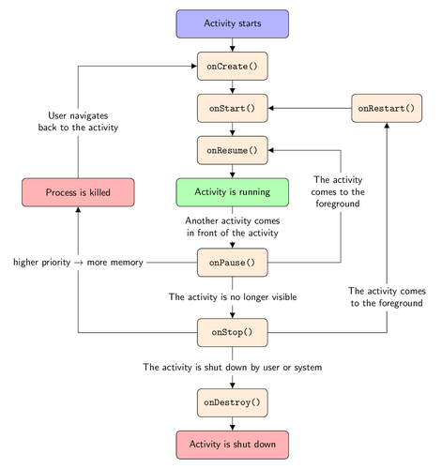

To navigate transitions between stages of the activity lifecycle, the Activity class provides a core set of six callbacks:

1) OnCreate()

2)OnStart()

3) OnResume()

4)OnPause()

5)OnStop()

6)OnDestroy().

The system invokes each of these callbacks as an activity enters a new state.

Activity is launched as soon as you click on an app. The moment you click on the icon of your app, the first method to be called is OnCreate() method. This method has SetContentView() function which tells your app to display the xml on UI. The moment your activity is going to be displayed, OnStart() method is called. Just after OnStart() method, OnResume() method is called which is the last method before your activity is showed on screen. The core functionality of the app is present in OnResume() method.

When another activity comes into the foreground, then the existing activity pauses and OnPause() method is called. We implement those functions in OnPause() method which we want to run when the activity has lost focus. When the activity is OnPause(), then it might be visible and its UI may be updated but when you open another app and minimize this one then this app goes in Stop phase where OnStop() method is called. In OnStop() method , if the other app needs more memory then this activity is killed and if you resume this app, it will start with OnCreate() method. If it is not required to kill this activity then once you resume your app, it will call OnRestart() method and immediately after this method OnStart() method is called.

Once you close your activity OnDestroy() method is called. Any connections that we have made with the server or any resources that we are using from the server are freed using best practices in this method.

**e) What are 5 different UI elements in an android app?**

TextView

EditText

ImageView

Button

CheckBox

**f) What are some of the salient features of those languages (part c)? How similar are they to C++?**

**Kotlin:**

It is an open source programming language.

One of the best features of Kotlin programming language is its deep interoperability with Java, which is bound to attract more Java developers to learn Kotlin. It runs on the JVM and uses Java libraries and tools. It offers backward compatibility for Java versions 6 and 7.

Kotlin is an object-oriented programming (OOP) language with support for higher-order functions and lambdas.

Both Kotlin and C++ are OOP languages.

**Java:**

Features of Java are:

1. Simple
2. Object-Oriented
3. Portable
4. Platform independent
5. Secured
6. Robust
7. Architecture neutral
8. Interpreted
9. High Performance
10. Multithreaded
11. Distributed
12. Dynamic

Similarities between Java and C++ are:

1) Both C++ and Java support Object Oriented Programming.  
2) They have similar syntax.  
3) Comments Syntax are identical.  
4) The loops (like while, for etc.) and conditional statements (like if-else, switch etc.) are similar.

5) Both have same arithmetic and relational operators.  
6) Execution of both the C++ and Java programs starts from the main function.  
7) They have same primitive data types.  
8) Many of their keywords are same.

Example: break, continue, char, double, new, public, private, return, static etc.

9) Both have multi-threading support.

**Task:**

I have made some of the activities for the App Book-ed!.

User Id for it is **Book** and password is **1234**.